Question Paper Set A1
AI-Assisted Coding Exam — Python (1 hour)
- You may either (a) write the exact prompt to have your AI assistant generate code, or (b) write the code yourself. If you use AI, submit the prompt and the final code you executed.
- Use VS Code Copilot / Gemini / CursorAI. Credit your prompts.
- Prefer Python standard library; write clear, tested, well-documented code.
- Each subgroup (A–O) has two tasks. Attempt all. Medium complexity, use-case based.
- Syllabus pillars:
A–C: AI completion (classes, loops, conditionals)
D–E: Debugging with AI
F–G: Code Quality & Performance
H–I: Documentation & Code Review
J–K: Code Quality & Performance
L–M: Debugging with AI
N–O: AI completion (classes, loops, conditionals)
Deliverables for each question
1) If using AI: the exact prompt you issued. If manual: note 'manual' and a brief design reason.
2) solution.py
3) tests.py (unittest/pytest; write tests first for TDD items)
4) Docstrings & inline comments (AI-assisted allowed)
5) Short README.md (approach, assumptions, complexity, run tests)
6) For debugging/refactor: brief before/after note
Question Paper Set A1

AI-Assisted Coding Exam — Python (1 hour)
- You may either (a) write the exact prompt to have your AI assistant generate code, or (b) write the code yourself. If you use AI, submit the prompt and the final code you executed.
- Use VS Code Copilot / Gemini / CursorAI. Credit your prompts.
- Prefer Python standard library; write clear, tested, well-documented code.
- Each subgroup (A–O) has two tasks. Attempt all. Medium complexity, use-case based.
- Syllabus pillars:
A–C: AI completion (classes, loops, conditionals)
D–E: Debugging with AI
F–G: TDD with AI
H–I: Documentation & Code Review
J–K: Code Quality & Performance
L–M: Files/CSV & Regex
N–O: AI completion (classes, loops, conditionals)

Deliverables for each question
1) If using AI: the exact prompt you issued. If manual: note 'manual' and a brief design reason.
2) solution.py
3) tests.py (unittest/pytest; write tests first for TDD items)
4) Docstrings & inline comments (AI-assisted allowed)
5) Short README.md (approach, assumptions, complexity, run tests)
6) For debugging/refactor: brief before/after note

Subgroup G

G.1 — [S01G1] Sum CSV column ignoring bad rows
Scenario (e-commerce):
Context:
Ad-hoc CSV exports in e-commerce contain missing/invalid numeric fields.

Your Task:
Sum the 'value' column as int, skipping invalid rows, and report total (print skipped count optional).

Data & Edge Cases:
id,value
1,10
2,NA
3,7 -> 17 with one skipped.

AI Assistance Expectation:
Use AI to draft robust CSV parsing with try/except and tests.

Constraints & Notes:
Print or return count of skipped rows for transparency.
Sample Input
id,value
1,10
2,NA
3,7
Sample Output
17
Acceptance Criteria: Skips invalid rows; correct total

Prompt:
write a python code in which it will find Sum the 'value' column as int, skipping invalid rows, and report's total and also counts the invalid rows in the csv file
Sample Input
id, value
1,10
2,NA
3,7
Sample Output
17

Code:
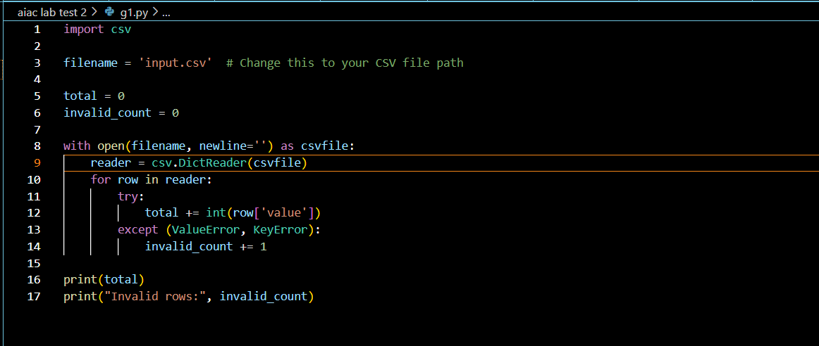
Output:
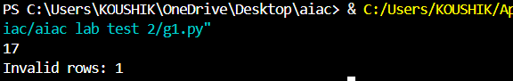

G.2 — [S01G2] Merge two CSVs by id
Scenario (e-commerce):
Context:
Two CSVs in e-commerce must be merged by 'id' for reporting.

Your Task:
Implement inner and left joins without pandas, following SQL semantics.

Data & Edge Cases:
A:id,price & B:id,qty -> inner join has only common ids; left join keeps all A with None for missing B.
AI Assistance Expectation:
Use AI to outline dict-building and join logic; write unit tests for both joins.
Constraints & Notes:
No external deps; stable output order preferred.
Sample Input
id,price
A,10
B,20
---
id,qty
A,2
C,5
Sample Output
inner=[('A',10,2)], left=[('A',10,2),('B',20,None)]
Acceptance Criteria: Correct join behavior

Prompt:
write a python code in which 2 csvs will be merged by id ,Implement inner and left joins without pandas, following SQL semantics and print the output
Sample Input
id, price
A,10
B,20
id, qty
A,2
C,5
Sample Output
inner=[('A',10,2)], left=[('A',10,2),('B',20,None)]

Code:
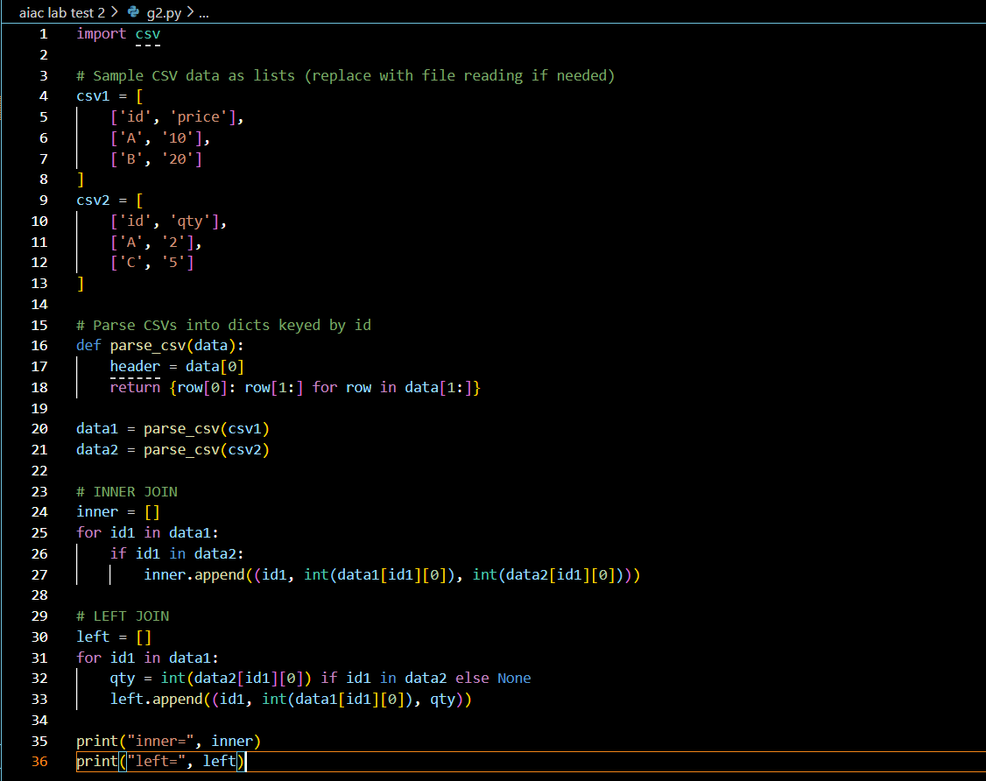

Output:
